Optical Pumping

Objectives
- To optically pump a sample of rubidium (Rb) atoms into a non-equilibrium state in which the atoms no longer absorb light and thus the sample becomes transparent.
- To use optical pumping to measure atomic parameters of rubidium.
- To use the optical pumping cell as a magnetometer to measure the local magnetic field.
Note: this experiment is both conceptually and experimentally very tricky. It is important to study diligently and make steady progress during lab.

References/Study Material
- Nonlinear Spectroscopy of Rubidium: an undergraduate experiment Eur. J. Physics
- Optical Pumping, Arnold Bloom, Scientific American
- Review atomic structure, fine structure, and hyperfine structure (with quantum numbers L, S, J, I, F) in your modern physics book.
- Description of the apparatus from TeachSpin, Inc. and the relevant manual. Note: some instructions are contained here, which you may use to familiarize yourself with the apparatus.
- Tour of the apparatus by Dr. Bensky
- Animation 1 and 2 created by Dr. Bensky

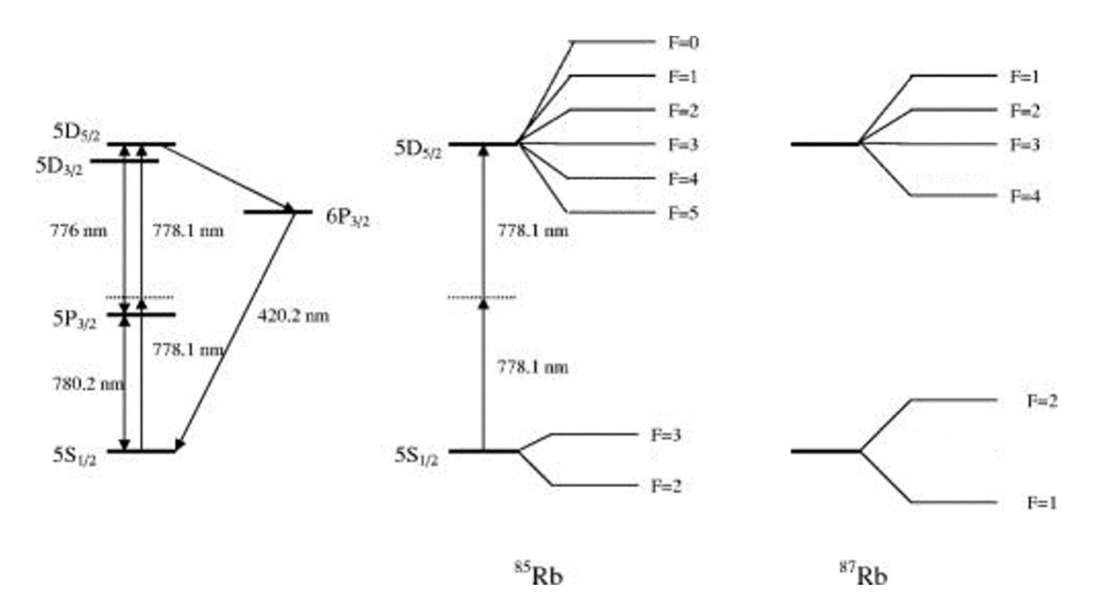
Figure 1: In this experiment, we will investigate the hyperfine structure of Rubidium-85 and Rubidium-87 (link to source for image). The phrase "hyperfine structure" refers to the quantized energy states from the electron-nuclear coupling quantum number F. Each of these states can be further split into mF states via the Zeeman Effect in the presence of an external magnetic field.

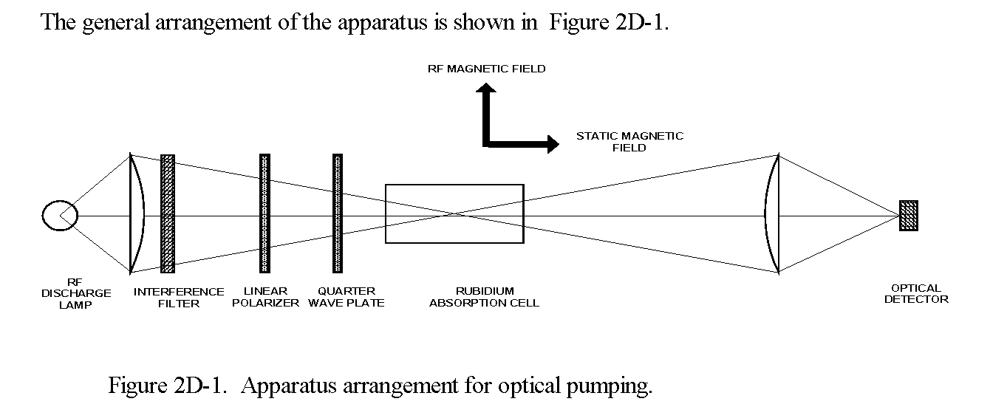

Art of the start
Do not start optical pumping just yet. You know from modern physics that if a photon energy matches the energy spacing of an (two level) atomic transition, then the photon will disappear and the electron will be excited to the higher of the two levels. Such an optical electron transition exists in the optical pumping and finding it is your “art of the start.”
Turn off the RF generator, next get a compass and be sure the optical rail points in the direction of north, as reported by the compass. Set a dual channel oscilloscope into XY mode. This allows you to see the detector response (intensity of the light coming through) as a function of the horizontal B-field sweep. Set the X channel to 2 V/div and the Y channel to 100 mV/div. Connect the “recorder output” to Channel X and the “Detector amplifier output” to Channel Y. Set the “Time” on the optical pumping control panel to 10 ms. Configure the oscilloscope display to be in “infinite persistence” mode.
The recorder output is a voltage that is proportional to the horizontal sweep magnetic field. Turn the Start field knob to zero (full CCW) and the Range knob to maximum (full CW). Toggle the switch from start to reset, then back to start again. The other toggle switch should be on “continuous.” You should see the trace on the oscilloscope scan from left to right over and over again. Adjust the oscilloscope so the entire sweep range appears within the bounds of the display. Next, turn the Vertical Magnetic Field knob to about 1.75, which corresponds to about 0.175 Amperes of DC current delivered to the vertical field Helmholtz coils. You should see a dip forming on the trace on the oscilloscope. The dip might be very gradual and corresponds to the Rb absorbing photons from the light source, in this case, the 794.8 nm light is stimulating the 52S1/2 to 52P1/2 transition.
You should now work to make this dip as narrow as possible.To start, make small adjustments in the vertical magnetic field by changing the current delivered to the vertical coils. Next, physically (and carefully) rotate the entire table the pumping unit is sitting on about an axis perpendicular to the ground. This will optimize the North-South orientation of the unit, ensuring the Rb-atoms experience only a vertical and horizontal magnetic component due to the Earth's field. You should be able to achieve a minimum width (the dip is as deep and as narrow as you can make it by adjusting Bvert and “rotating” the table). Take your time doing this. If you do not have a good zero-field signal, you will not be able to measure good data. Seeing, optimizing, and understanding this dip is your “art of the start” for optical pumping.
Equipment Tour
Optical Rail (in order): (there is no need to move any of these components)
- Rb lamp (emits at 780 nm and 794.8 nm light).
- 50 mm lens.
- 794.8 nm bandpass filter.
- Linear polarizer.
- Quarter wave plate.
- Plexiglass container enclosing the Rb-cell (containing Rb85 and Rb87 vapor). Cell is temperature controlled as per the “Cell Heater/Controller” panel.
- Four Helmholtz coils: Horizontal (not present), vertical, horizontal sweep, and RF.
- Another 50 mm converging lens.
- Amplified photo-detector (output voltage proportional to the light intensity).
Controls and connectors
- Detector amplifier: Input from photo-detector on rail, to be amplified, then output sent to oscilloscope.
- Vertical and Horizontal Magnetic Fields. Knobs control current into each of these Helmholtz coils. Current = knob-setting/10 Amperes.
- Horizontal Magnetic Field Sweep Coils. Independently wrapped on top of the horizontal field
windings (use the same supports) are additional windings. Controlled with “Horizontal Magnetic Field Sweep.” Sweeps the horizontal B-field between “Start field” and “Start field + Range.” The sweep can be continuous or single, taking “Time (seconds)” to complete.
- Horizontal sweep can be monitored on 1) recorder output (each 50 mV = 1 mG), or 2) voltage proportional to B-fields on “Monitor” jacks. The monitor jacks of the vertical coils are on the back of the box.
- RF amplifier. Input is connected to the external RF function generator, output to the RF Helmholtz coils. In the upper left corner of the control panel is the RF amplifier gain knob. The gain knob sets the multiplicative gain of the RF.

Optical Pumping as a Magnetometer
Geophysicists use “rubidium magnetometers” to make precise measurements of the Earth’s magnetic field. They work just like the experiment you’re doing. You’ve already determined the horizontal component of the local magnetic field, B_{H}. What about the vertical field?
You’ve already adjusted the vertical field of the Helmholtz coils to match (and cancel) the vertical component of the local field. To determine its field, using the Helmholtz equation, you need to know how much current is going through the coils by measuring the voltage across a pair of terminals on the back of the control panel. The current to the coils passes through a 1.00 Ω precision resistor, so you can use Ohm’s law to deduce the current. Call the vertical component of the Earth’s field B_{V}.
Determine the magnitude of the local field, in gauss, and the angle of the field below horizontal. This angle is called the dip angle. How does it compare with the Earth’s field at the location of San Luis Obispo, a quantity you should be able to find on the internet? Our location on Earth is 35°17′ N, 120°40′ W. Because we’re in a building with lots of steel, the local field will not be exactly the “true” value, but it won’t be too far off.
You can place a magnetic “dip meter” near your work area to directly measure a value for the angle of the local magnetic field. And you might want to take the dip meter outside for comparison.

Technical Questions
Observations
- Show a graphic of the oscilloscope trace showing the RF resonances of Rubidium. Identify all the peaks with respect to the isotopes of Rubidium.
- Discuss why the Rb87 resonance appears at a lower sweep field than the Rb85 resonance.
  - What happens to the resonances as you change the RF frequency? Why?
  - What happens to the resonances as you change the magnetic field (i.e., the horizontal sweep field)? Why?
The apparatus
- Make a sketch or drawing of the optical rail and describe what each element does and what purpose it serves
- Discuss why this experiment is called "Optical Pumping."
Atomic structure of rubidium
- Report a table (or tables) of the appropriate data to create the plot in question 3. (Note: how many tables are needed is up to your discretion; make sure the information is complete, legible, and formatted correctly).
- Create a plot of the B field and the Rf frequency for each Rb isotope. Extract the Lande g factor, gF for each rubidium isotope. Show error bars and report with a 68% confidence interval.
- Find a scientific article or national laboratory database that reports gF for Rb85 and Rb87. Quantitatively compare the two measurements. Cite your research.
Local/External Field
- Report a magnitude and direction (dip angle) of the local, external field in the room and compare it to “looked up” values for the field at your GPS coords. You also have a “dip angle” compass to measure direction.

Transient Effects (Bonus, not required, only if you have time)
- When your photodiode signal is “high”, the most light is making it through the Rb gas, which means your sample is “pumped”. Becoming “pumped” happens very quickly, but this transient time to become pumped can be measured. Determine/measure this time by modulating (turn on and off quickly) the RF. Use the square wave function generator in the oscilloscope, connected to the modulation input on the Teachspin box, to do this. Before, you will also need to stop sweeping the horizontal field and move it to sit on one of the Rb resonance dips corresponding to the RF frequency. Look in the TeachSpin manual at the end in experiments for some instructions and ask your instructor for help. We hope you give this a try.
Note: This is a very complex experiment. You should start on this lab report as soon as possible in order to capture all the nuances.

More reference info
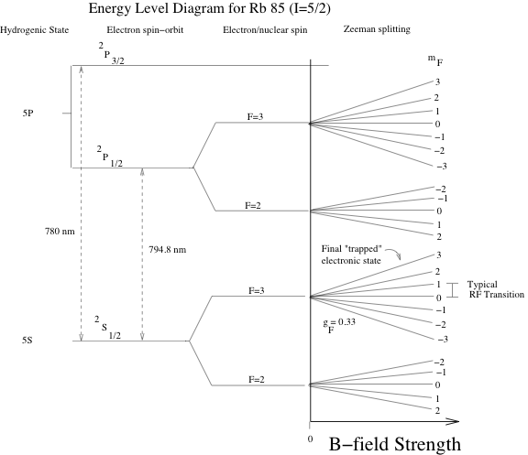
Figure 3: Structure of the ⁸⁵Rb isotope (not to scale).

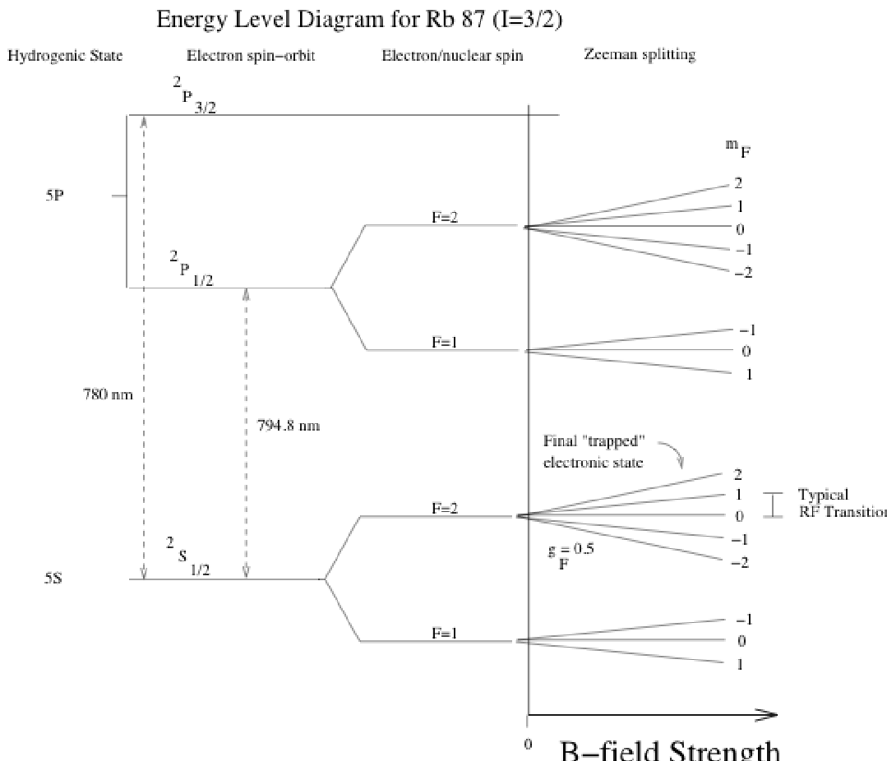 Figure 4: Structure of the ⁸⁷Rb isotope (not to scale).

What Optical Pumping Is All About

Pumping
At 50 °C, the density of rubidium atoms is high enough that most 795 nm radiation is absorbed while passing through the cell by the 5S_{1/2} to 5P_{1/2} transition. That is, the cell is very nearly opaque to 795 nm light. In general, all the hyperfine and Zeeman levels of the 5S_{1/2} ground state are equally populated. But suppose we could arrange it so that all the ⁸⁵Rb atoms were in one state, the 5S_{1/2}, F=3, m_{F} = +3 state (see Figure 1). Further, suppose the incoming 795 light has been right circularly polarized. Given what you now know from the previous section about selection rules, how would the rubidium gas appear to the excitation light?
If you answered “completely transparent,” you would be correct. Why? Remember the excitation light is right circularly polarized. Any absorption of these photons by rubidium atoms requires ∆m_{F} = +1. But an atom in the m_{F} = +3 state cannot absorb a photon because the 5P_{1/2} level has no m_{F} = +4 state for it to enter! If all the atoms are in the m_{F} = +3 state, then no photon absorption can occur. The same scenario applies to the ⁸⁷Rb isotope if all the atoms are in m_{F} = +2, since no m_{F} = +3 state is available in the 5P_{1/2} level. For both isotopes, ground state atoms with the maximum possible value of m_{F} are unable to absorb 795 nm light if the light has been right circularly polarized.
So what? We noted earlier that, in thermal equilibrium, all the different states are equally populated. In general, atoms with other values of m_{F} can absorb light, which is why the sample is opaque to 795 nm light. To make the gas transparent, we would need to get all the atoms into the state of maximum m_{F}, a very non-equilibrium situation. But that’s what optical pumping does.
Consider shining right circular polarized 795 nm light on a gas of rubidium atoms in thermal equilibrium. We’ll focus on ⁸⁵Rb atoms, but the same thing happens for ⁸⁷Rb. Initially, all the states are equally populated. An atom with m_{F} = –3 can absorb a photon, but to do so it has to obey the ∆m_{F} = +1 selection rule and go to 5P_{1/2}, F = 2 or 3, m_{F} = –2. A short time after being excited, the atom is going to emit a photon and jump back to the ground state. The emitted photon can have ∆m_{F} = –1, 0, +1, so the atom can drop back to a state with m_{F} = –3, –2, or –1. Because not all atoms return to the m_{F} = –3 state, where they started, there’s been a net “upward” transfer of atoms to states with higher m_{F}. This is the essence of optical pumping.
Now continue this absorption/re-emission process over and over. During each up-down cycle, an atom can increase its value of m_{F}, but it can never decrease m_{F}. Make sure you understand this, because it’s the key idea. It’s like a ratchet that can turn one way but not the other. After many cycles, the entire population has been “pumped” into the state of maximum m_{F}, and there it’s “trapped” because the selection rules now prevent any further absorption of photons. This is what optical pumping is all about: trapping the atomic population in a non-equilibrium state where is it restricted from further photon excitation by selection rules. And once all the atoms are in the state of maximum m_{F}, the atomic gas – which is no longer absorbing photons – becomes transparent. You’ll measure how long the pumping process takes, but it’s typically 10–20 ms.

De-pumping
Suppose you have an optically pumped sample. The sample is transparent to right circularly polarized 795 nm radiation, so a photodetector behind the gas has a maximum signal. Now suppose you do something to the system that moves atoms into states with lower values of m_{F}. That is, you force atoms to “leak” out of their  states. What would happen?
The photodetector signal would abruptly drop, because you will have created a whole set of atoms that do not have 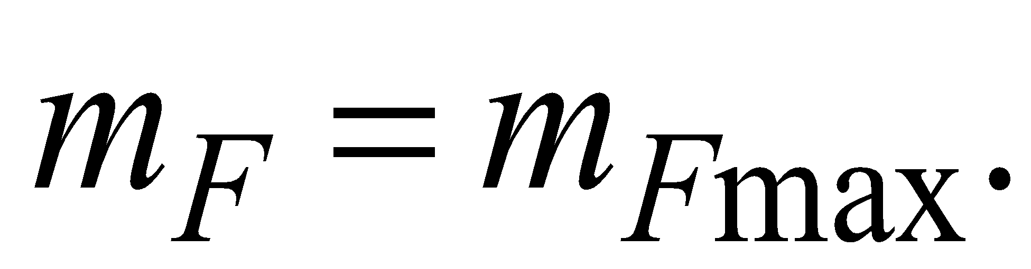 These atoms are available to absorb light, so the amount of light passing through the sample decreases. We say that you have de-pumped the sample.
Although there are various ways to de-pump the sample, in this experiment we are going to do so using radio-frequency (RF) photons to cause transitions between neighboring Zeeman states. If you look at Figures 1 and 2, you’ll see transitions between neighboring Zeeman states (∆m_{F} = ±1) labeled as “typical RF transitions.” At the magnetic fields you’ll be using, these level spacings correspond to frequencies of roughly 100 kHz, which are easily generated. After you’ve pumped all the atoms to the state of maximum m_{F}, and the gas has become transparent, turning on the RF at the correct frequency will drive some atoms back to the 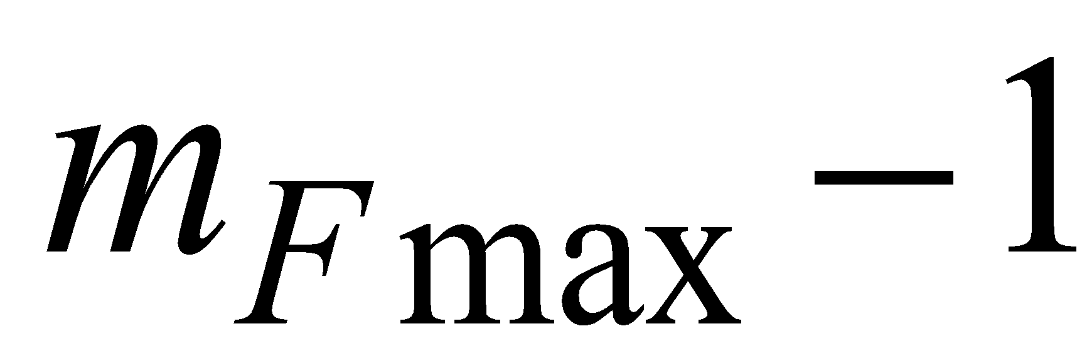 state, where they will start absorbing photons. The loss of photo-detector signal will be the indication that the applied RF is in resonance with the atomic transition. Accurate measurements of the transition frequencies at various magnetic fields will allow you to measure g_{F} for both isotopes of rubidium.

Helmholtz Coil Info
Horizontal | Typically set to zero | R = 15.8 cm | N = 154 turns
Horizontal Sweep |  | R = 16.3 cm | N = 11 turns
Vertical |  | R = 11.7 cm | N = 20 turns
RF |  | R = 3.22 cm | N = 3 turns

